SEWP VI Onboarding – Contract Holder Checklist

 |  |  |  | SEWP Onboarding Staff |  | Click or tap here to enter text.
 |  |  |  | ServiceNow Case No. |  | Click or tap here to enter text.
CONTRACT HOLDER/COMPANY NAME
Full Name |  | Click or tap here to enter text.
CONTRACT NUMBER(S)
Note: The awarded contract number(s) for your company is(are) listed below. You will not see a contract number listed in a category you were not awarded in.
Example – If you were only awarded a Category A contract, there will not be a contract number listed in the Category B and Category C columns
Category A |  |  | Category B |  |  |  | Category C
Click or tap here to enter text. |  |  | Click or tap here to enter text. |  |  |  | Click or tap here to enter text.
DELIVERABLES/ACTIONS
Provide contact information (first name, last name, and email) for Program Manager (PM) and Deputy Program Manager (DPM)  ACTION: Reply all to the NASA SEWP VI Contract Holder Onboarding email thread with your company’s PM and DPM contact info (first name, last name, email)  NOTE: There are several actions on this form that require CHOP access. Please provide contact information for your PM and DPM ASAP |  |  |  |  |  |  |  | ☐
Complete Contract Holder Only Page (CHOP) registration (PM and DPM)  ACTION: You will receive an email from the PMO with the subject “SEWP VI: New user account created.” Complete registration per the instructions in the email. |  |  |  |  |  |  |  | ☐
Add contact info for PM and DPM in CHOP. Once entered, designate accordingly  ACTION: Add PM/DPM designation in the CHOP under contacts  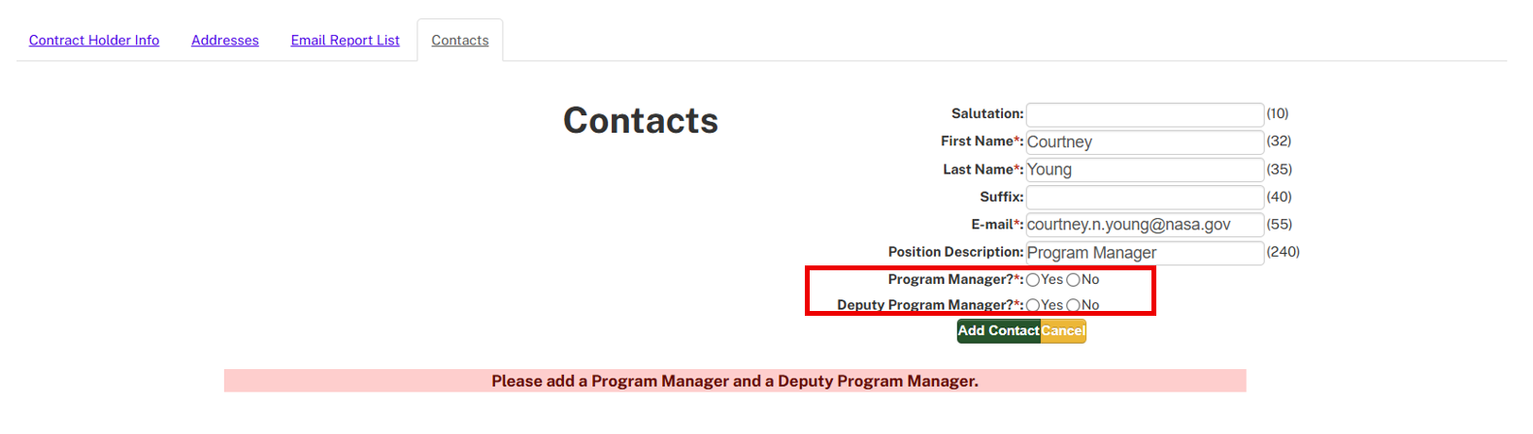 |  |  |  |  |  |  |  | ☐
PM and DPM sign up to receive the reports listed below  ACTION: Sign up for reports in the CHOP under Email Report List  NOTE: This can’t be completed until your PM/DPM have registered for the CHOP, which requires you to first identify who they are by responding to this email thread  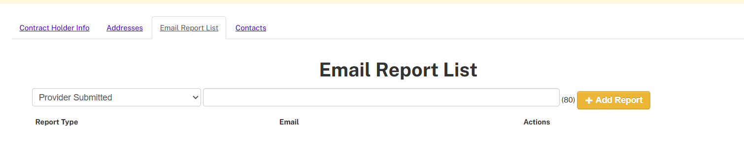 |  |  |  |  |  |  |  | ☐
- Order Emails | - Quote Request E-mails
- TR In | - TR In – Validation |  |  |  | - TR Approval Outcomes
Add URL to a SEWP dedicated page or contract page that includes SEWP info and Ordering Guide to CH Info  ACTION: Add company URL (A.5.1 World Wide Web Services) in the CHOP under CH Info. Webpage must include a compliant ordering guide (A.6. Ordering Guides). If you currently do not have a webpage that meets this requirement, please add a URL to your company homepage.  NOTE: This can’t be completed until your PM/DPM have registered for the CHOP, which requires you to first identify who they are by responding to this email thread  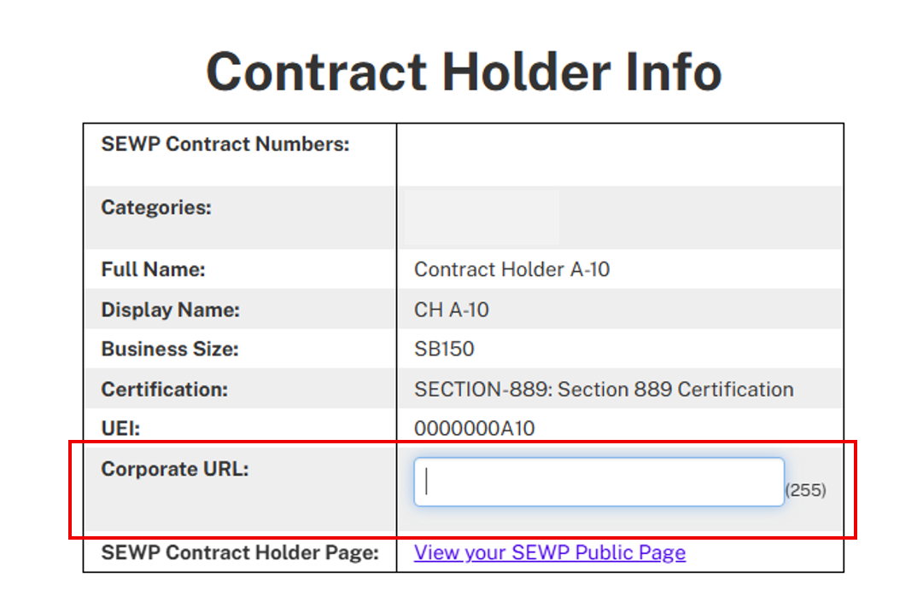 |  |  |  |  |  |  |  | ☐
**Provide credit card fee percentage  ACTION: Reply all to the NASA SEWP VI Contract Holder Onboarding email thread with your company’s credit card fee percentage |  |  |  |  |  |  |  | ☐
Provide company logo (PNG file format only)  ACTION: Reply all to this email thread with your company’s logo |  |  |  |  |  |  |  | ☐
Provide updated Exhibit 4 Crosswalk - A copy is attached to the NASA SEWP VI Contract Holder Onboarding email as well as on the SEWP VI site. Do not use the RFP version or any other previous versions of this form.  ACTION: Reply all to the NASA SEWP VI Contract Holder Onboarding email thread with your company’s completed NAICs crosswalk. A copy of the form is attached to this email and can be found on the VI Site. Enter business size for each NAICs as of TBD |  |  |  |  |  |  |  | ☐
Provide updated C-SCRM Attestation Form or current ISO 20243 Certification – A copy of the C-SCRM Attestation Form is attached to the NASA SEWP VI Contract Holder Onboarding email as well as on the SEWP VI site.  ACTION: Reply all to the NASA SEWP VI Contract Holder Onboarding email thread with your company’s completed C-SCRM Attestation Form or ISO 20243 Certification |  |  |  |  |  |  |  | ☐

**The credit card percentage fee does not need to be provided/completed for you to be considered an active Contract Holder

